**Jazz and Heritage**

The New Orleans Jazz & Heritage Festival (commonly called Jazz Fest or Jazzfest) is an annual celebration of local music and culture held at the [Fair Grounds Race Course](https://en.wikipedia.org/wiki/Fair_Grounds_Race_Course) in [New Orleans, Louisiana](https://en.wikipedia.org/wiki/New_Orleans). Jazz Fest attracts thousands of visitors to New Orleans each year. The New Orleans Jazz & Heritage Festival and Foundation Inc., as it is officially named, was established in 1970 as a 501(c)(3) [nonprofit organization](https://en.wikipedia.org/wiki/Nonprofit_organization) (NPO). The Foundation is the original organizer of the New Orleans Jazz & Heritage Festival presented by [Shell Oil Company](https://en.wikipedia.org/wiki/Shell_Oil_Company), a corporate financial sponsor. The Foundation was established primarily to redistribute the funds generated by Jazz Fest into the local community. As an NPO, their mission further states that the Foundation "promotes, preserves, perpetuates and encourages the music, culture and heritage of communities in Louisiana through festivals, programs and other cultural, educational, civic and economic activities". The founders of the organization included pianist and promoter [George Wein](https://en.wikipedia.org/wiki/George_Wein), producer [Quint Davis](https://en.wikipedia.org/wiki/Quint_Davis) and the late [Allison Miner](https://en.wikipedia.org/wiki/Allison_Miner).

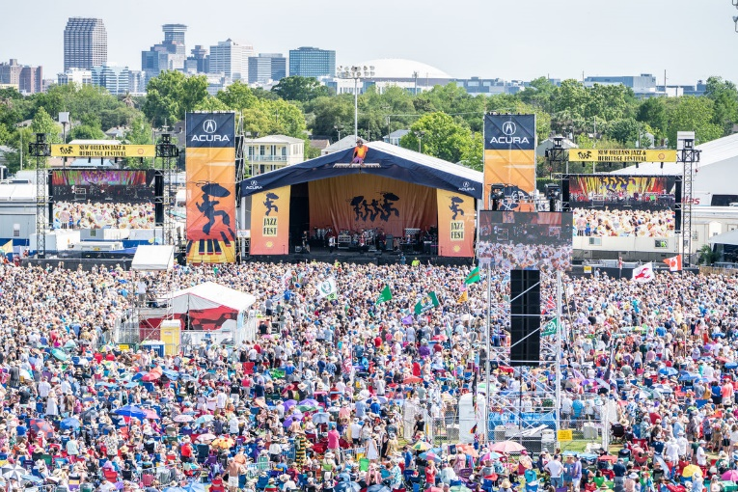

The Festival features a variety of local food and craft vendors. The official food policy of the Festival is "no carnival food".[[17]](https://en.wikipedia.org/wiki/New_Orleans_Jazz_%26_Heritage_Festival#cite_note-Official_website-17) There are more than seventy food booths that include local dishes like [crawfish beignets](https://en.wikipedia.org/wiki/Crayfish#Food), [cochon de lait](https://en.wikipedia.org/wiki/Cochon_de_lait" \o "Cochon de lait) sandwiches, alligator sausage [po' boy](https://en.wikipedia.org/wiki/Po%27_boy) (sandwich), boiled crawfish, softshell crab po'boy, Cajun [jambalaya](https://en.wikipedia.org/wiki/Jambalaya), jalapeño bread, fried green tomatoes, Oyster patties, [muffulettas](https://en.wikipedia.org/wiki/Muffuletta), red beans and rice, and [crawfish Monica](https://en.wikipedia.org/wiki/Crawfish_Monica). Vegan and vegetarian options are also available. All food vendors are small, locally owned businesses. Jazz Fest ranks second to Mardi Gras in terms of local economic impact.

Craft vendors are set up throughout the grounds, as are craft-making demonstrations. There are three main areas including the Congo Square African Marketplace, which features crafts from local, national, and international artisans; the Contemporary Crafts area, which features handmade clothing, leather goods, jewelry, paintings, sculptures, and musical instruments; and the Louisiana Marketplace, which displays baskets, hand-colored photographs, jewelry and landscape-themed art.

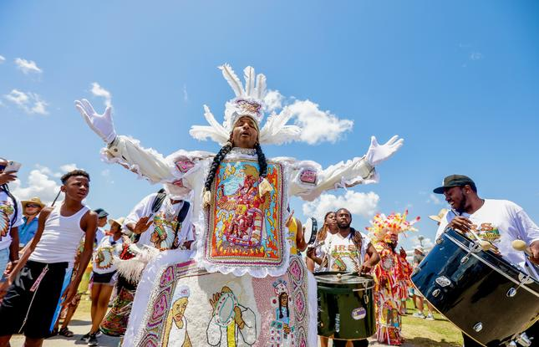

The Festival allocates large areas dedicated to cultural and historical practices unique to Louisiana. There are depictions of the many cultures that exist in the state, such as the Cajun culture, and the [Los Isleños](https://en.wikipedia.org/wiki/Isle%C3%B1o_American), who are descendants of native Canary Islanders. Some of the areas include the Louisiana Folklife Village, which focuses on state art and culture, the Native American Village and the Grandstand. The [National Endowment of the Arts](https://en.wikipedia.org/wiki/National_Endowment_of_the_Arts) has recognized many the work of many of the folk demonstrators.

Parades are also held throughout the event. They include parades by the Mardi Gras Indians, marching bands, brass bands, and social aid and pleasure clubs.